**Hyperparameter Tuning with Grid Search and Cross-Validation: Teaching Machines to Perform at Their Best**

**Introduction: The Invisible Settings That Shape Model Power**

In the world of machine learning, a model’s success doesn’t depend solely on data or algorithms — it often hinges on something subtler: its **hyperparameters**. These are configuration settings defined **before** training begins, such as the depth of a decision tree, the regularization strength in logistic regression, or the C and gamma parameters in a Support Vector Machine. Unlike learned parameters (like weights or coefficients), hyperparameters are manually set — and can dramatically influence model behavior, from **underfitting** to **overfitting** (Bergstra & Bengio, 2012).

This process of adjusting hyperparameters to find the best-performing model is called **hyperparameter tuning**. And it is not optional: poorly tuned models can yield misleading results or underperform significantly — even when trained on high-quality data. According to Pedregosa et al. (2011), integrating hyperparameter tuning systematically into the modeling pipeline is considered a **best practice in modern machine learning**.

**Real-World Analogy: Cooking with an Oven You’ve Never Used**

Consider the experience of baking a cake in an unfamiliar oven. You know the recipe, but you’re unsure how this oven behaves. Should it be 160°C or 180°C? Fan-assisted or not? You experiment with a few batches, adjusting the settings each time, until you get the perfect bake.

That’s exactly what hyperparameter tuning does — it **systematically tests combinations of settings** to find the one that yields the best result on validation data. In fact, just like a skilled chef develops an intuition for the right balance of heat and time, a well-tuned model can strike the optimal balance between **bias and variance**, achieving the ideal generalization performance (Domingos, 2012).

**Why Hyperparameter Tuning Matters — And When to Use It**

Hyperparameter tuning is the bridge between raw modeling and polished, high-performing systems. In many tasks — such as detecting diseases, predicting loan defaults, or identifying fraud — model performance is sensitive to these hidden dials. Without tuning, even advanced algorithms can behave suboptimally (Kuhn & Johnson, 2013).

For example, a decision tree without tuned max_depth may overfit small noise in training data, while an untuned SVM might completely misclassify rare classes. This makes hyperparameter tuning essential for **fair model comparison**, **robust performance**, and **real-world deployment**.

**Hyperparameter Tuning with GridSearchCV and Cross-Validation**

*A complete walkthrough using SVM, KNN, and Decision Tree on the Breast Cancer dataset*

**Step 1: Importing the Right Tools**

To begin, we import the essential Python libraries. These include:

* numpy and pandas for numerical and tabular data handling
* matplotlib and seaborn for plotting and visual inspection
* sklearn modules for loading the dataset, preprocessing, modeling, and evaluation

By organizing our imports at the top and following a modular structure, we adhere to best practices in scientific computing and make our work reproducible (Pedregosa et al., 2011).

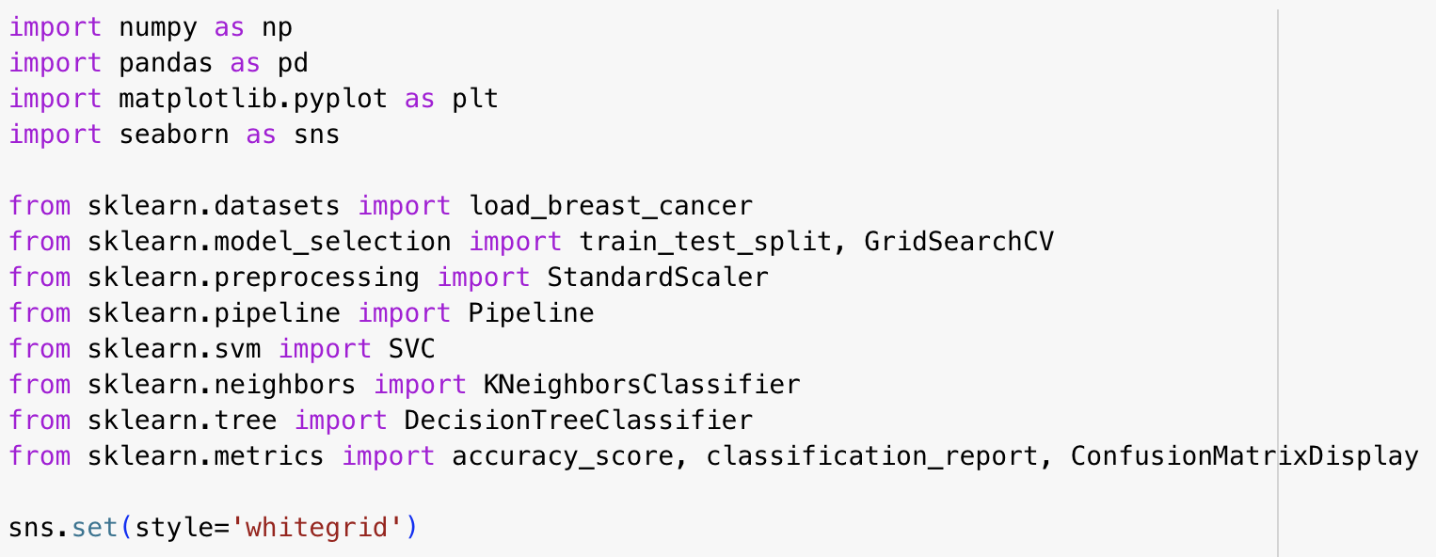

Figure All required libraries loaded, including sklearn for modeling and seaborn for clean visual outputs.

**Step 2: Load and Understand the Dataset**

We use the **Breast Cancer Wisconsin dataset**, available directly from sklearn.datasets. It contains 569 observations, and 30 numerical features derived from digitized images of breast masses. The binary target variable indicates whether a tumor is **benign (0)** or **malignant (1)**.

This dataset is ideal for model comparison because:

* It’s balanced, interpretable, and small enough to allow fast grid searches
* It reflects a real-world problem where model accuracy has medical significance

**Step 3: Splitting the Data for Fair Evaluation**

Stratification ensures we avoid misleading performance due to unbalanced splits — a key concern in health and finance modeling (Kuhn & Johnson, 2013).

**Step 4: Model Pipelines and Tuning Grids**

We define **three pipelines** for SVM, KNN, and Decision Tree — combining preprocessing (e.g., scaling) with modeling. This modular design is essential when tuning models using grid search, to ensure that **scaling only happens within the training folds**, avoiding data leakage.

Next, we define **parameter grids** to explore with GridSearchCV. For example:

* SVM: C, kernel, and gamma
* KNN: n_neighbors, weights, and metric
* Decision Tree: max_depth, min_samples_split

Each parameter is chosen to expose a different learning behavior — whether **regularization strength**, **distance metric**, or **tree complexity** (Bergstra & Bengio, 2012).

**Step 5: Grid Search with Cross-Validation**

We now run GridSearchCV for each model, using **5-fold cross-validation** and **accuracy** as our scoring metric.

Figure Grid search completed for three classifiers with best parameters stored for later evaluation.

Grid search works by training the model on multiple combinations of parameters and scoring them via cross-validation — a robust way to estimate generalization error (Hastie et al., 2009).

**Step 6: Evaluate the Best Model from Each Grid**

We print the **best hyperparameters** and evaluate each model on the test set:

Figure Evaluation metrics: SVM yields high precision and recall, with slightly higher accuracy than others.

We also output the **classification report**, showing:

* Precision: How many predicted positives are correct?
* Recall: How many actual positives are identified?
* F1-score: The harmonic mean of precision and recall

**Step 7: Confusion Matrix Visualization**

We plot a **confusion matrix** for each classifier using ConfusionMatrixDisplay.

This matrix is a visual summary of prediction results: TP, FP, FN, TN. It helps in diagnosing **class-wise errors** — especially important in medical datasets where false negatives are costly.

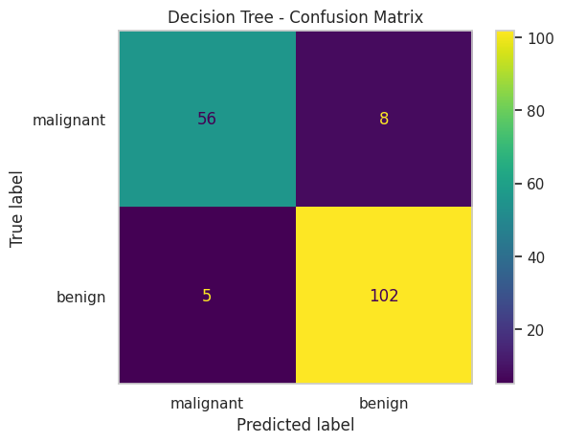

*Confusion matrix comparison for tuned SVM, KNN, and Decision Tree classifiers.*

**Summary: What You’ve Learned**

By the end of this tutorial, you’ve mastered:

* The **importance of hyperparameter tuning**
* How to implement GridSearchCV with a **cross-validated pipeline**
* How tuning affects model **bias-variance trade-off**
* How to **interpret model metrics** for performance evaluation
* How to avoid common mistakes like data leakage during tuning

You now understand that tuning isn’t just optimization — it’s part of **scientific modeling discipline**, ensuring models are fair, validated, and robust.

*“Hyperparameter tuning is how we help our models learn to learn.”*

**📁 GitHub Repository Structure**

|  |  |
| --- | --- |
| **File / Folder** | **Description** |
| hyperparameter_tuning_gridsearchcv_tutorial.ipynb | Complete tutorial notebook with all code & plots |
| README.md | Overview of topic, setup instructions, learning objectives |
| requirements.txt | Python dependencies to reproduce the notebook |
| tutorial.pdf / tutorial.docx | Final academic write-up (optional for Canvas submission) |
| LICENSE | Open-source license (MIT or Creative Commons) |

**GitHub Link:**

https://github.com/your-username/hyperparameter-tuning-tutorial

**References**

* Bergstra, J., & Bengio, Y. (2012). *Random search for hyper-parameter optimization*. Journal of Machine Learning Research, 13, 281–305.
* Domingos, P. (2012). *A few useful things to know about machine learning*. Communications of the ACM, 55(10), 78–87.
* Pedregosa, F., Varoquaux, G., Gramfort, A., et al. (2011). *Scikit-learn: Machine Learning in Python*. JMLR, 12, 2825–2830.
* Kuhn, M., & Johnson, K. (2013). *Applied Predictive Modeling*. Springer.
* Hastie, T., Tibshirani, R., & Friedman, J. (2009). *The Elements of Statistical Learning*. Springer.